**San Francisco Bay University**

**CS483 - Fundamentals of Artificial Intelligence**

**Homework Assignment #1**

**Due day: 5/28/2022**

**Instruction:**

1. **Push the program source code to Github**
2. **Overdue homework submission could not be accepted.**
3. **Take academic honesty and integrity seriously (Zero Tolerance of Cheating & Plagiarism)**

1. Given a training set of patient records of Systolic Blood Pressure (SBP) regarding **two**

features, such as *age* and *weight*, please build up linear regression hypothesis function/loss function /cost function, and then write python program to implement this algorithm by gradient descent method. After hypothesis function training through training set, predict new patient’s SBP

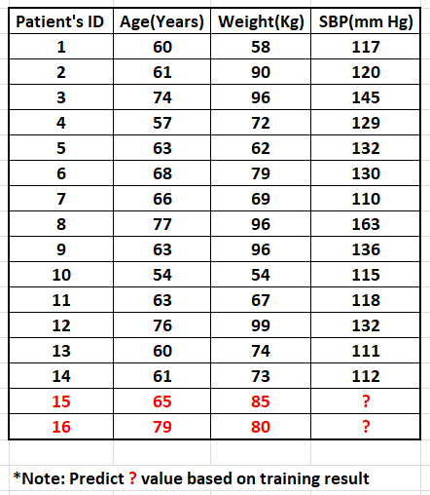

2. Assuming that *Y* is the function of *X* in the following training set, please try to take second-order hypothesis function to fit *(X,Y)* coordinate points by curve ***Y = f(X).*** Before writing **python** program to implement regression by gradient descent algorithm, hypothesis function/loss function/cost function are needed for getting all the parameters *θs* in hypothesis. After training regression module, plot *(X,Y)* points and the fitting curve by **matplotlib** python functions

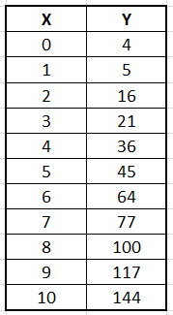

3. Write Python program to find the parameters *θs* in the hypothesis function for the above dataset (dataset in q2) by Cramer’s rule. And compare the results with those coming from gradient descent algorithm